1. Epoch.

To see when to stop or which epoch is good, should seed all of these four parameters

With epoch increasing, Test loss stably decrease until epoch 12, start oscillating

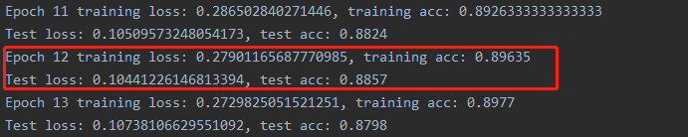

The best group:

\*\*Group: 6; Epoch: 35; Batch Size: 64; lr: 0.9; training loss: 0.18424539784315044; training acc: 0.9311166666666667; test loss: 0.09712950838034723; test acc: 0.8961;

1. Batch size

When turn down batch size to 32

1. Similar start

Group 9:

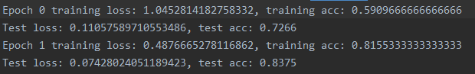

G6:

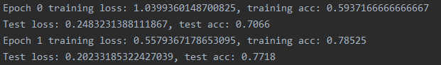

Small batch size converge faster

First step into 0.2+

G9:

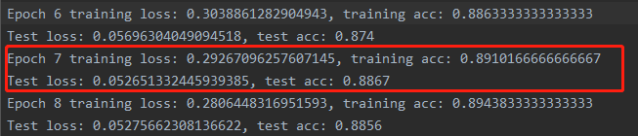

G6:

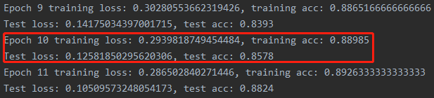

Test losses are very different. Almost double.

Oscillation start at epoch 22

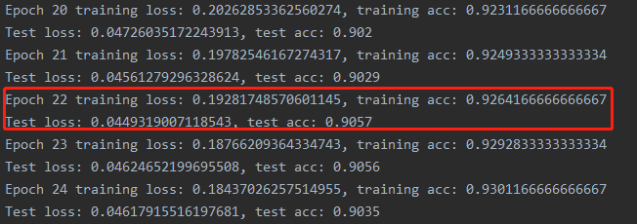

Converge fast